Instructions for author: writing an abstract to be submitted to
CMIS 2024

First A. Author, Presenting Author and Third B.C. Author

Write affiliation here. If you need more than one affiliation use numbering.

This document will help you prepare your abstract (maximum 1 page, including figure and references) for CMIS 2024. Please use exclusively this template to write your abstract as it contains all the necessary styles and page set-up and is ready to use.
Avoid individual formatting of headings and text as much as possible. Use the paragraph styles as defined in this document to format the layout of your abstract. The abstract may contain no more than one figure (a single figure spans the entire width, see for example Figure 1, composed of two sub-figures). You may include equations and references.

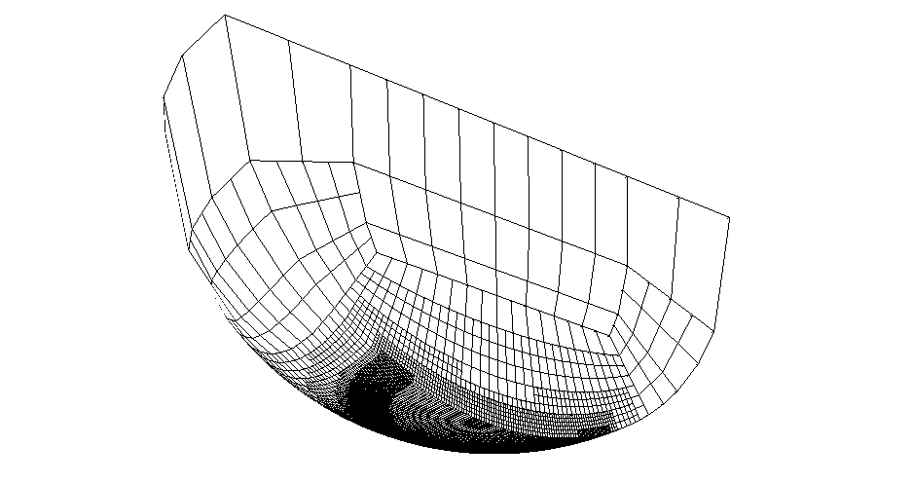 | 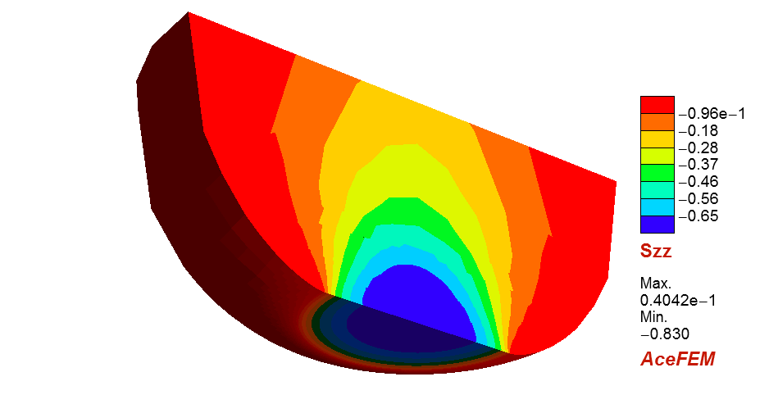
(a) | (b)
Figure 1: Soft-EHL problem: (a) mesh in undeformed configuration, (b) σ_{zz} component of the Cauchy stress tensor in the deformed configuration.

Set-up: Font is Times New Roman. Use A4 paper with top and bottom margins of 2.54 cm (1 inch) and left and right margins of 3.17 cm (1.25 inches). Do not include page numbers nor page header/footer. Footnotes are not allowed.
Title: The title is typed in bold, 14pt, centered. Do not capitalize words in the title, except the first word of the title or proper nouns. Between title and authors list there is a blank line.
Authors: The authors are listed in one paragraph in 12pt, centered. Put first name, initials and last name. Use super-scripted numbering if authors have a different affiliation.
Affiliation: Affiliation and e-mail address are in 10pt, italic, centered. Different affiliations are put in separate paragraphs and numbered with the super-scripted numbers used in the authors list. If no e-mail address is available, add a fax-number.
Body text: The remainder of the abstract is made of paragraphs, (no numbered sections) justified at both left and right margins and in 11pt.
References: numbered as [1], [2, 3], [1-3] and listed in numerical order following the text body. Work accepted for publication should be referred as “in press”. References to unpublished data cannot be cited. Reference list is in 10pt.
References
[1] P. Wriggers. Computational Contact Mechanics, 2nd ed., Springer, 2006.
[2] G. Zavarise, P. Wriggers, Contact with friction between beams in 3-D Space, Int. J. Num. Meth. Engng., 49:977-1006, 2000.
[3] T. Laursen and J.C. Simo, A continuum-based finite element formulation for the implicit solution of multibody, large deformation frictional contact problems, Int. J. Num. Meth. Engng., 36:3451–3485, 1993.

